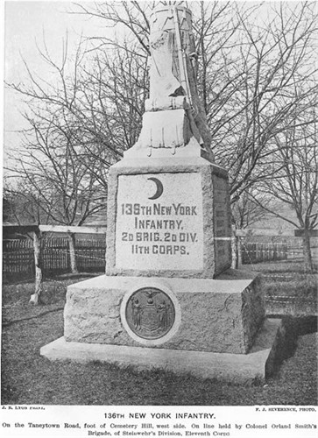
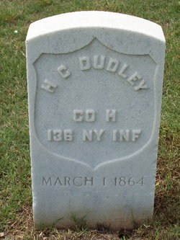
Today, July 2, 150 years ago my 2nd great grandfather’s 136th New York Infantry Regiment, the “Ironclads”, was engaged in the defense of Cemetery Hill at Gettysburg, Pennsylvania during the 2nd day of battle. His name was Harlow Gillette Dudley (1828-1864). He was a farmer at Bennington, Wyoming County, New York, and a family man. He was married to Susan J Melvin and they had 3 children: Joseph Andrew, Josephine E., and Jenny C. (my great grandmother Hankey). He enlisted as a private on 15 September 1862 in Company H of 136th New York Infantry Regiment. The unit mustered at the “parade ground” which is now found within the boundaries of Letchworth State Park. The regiment left NY on October 3, 1862; and was assigned to the 2nd Brigade, 2nd Division, 11th Corps of the Army of the Potomac. Harlow survived the 2nd day’s battle for Cemetery Hill at Gettysburg and went with regiment in September when the 11th corps was sent to Chattanooga, Tennessee as part of a force gathered to relieve the besieged Army of the Cumberland. At Chattanooga his unit was engaged in the battles of Wauhatchie, Lookout Mountain, and Missionary Ridge which resulted in the breaking of the siege and the rout of the confederate Army of Tennessee. Harlow Dudley survived these actions. He died at Lookout Valley, TN of lung inflammation (pneumonia) on March 1, 1864. His diary was sent to his wife by officer Gad Parker. He was buried by his comrades at the Chattanooga National Cemetery in plot B-197(now section B plot 640). His wife and children received a survivor’s pension of less than $100 a year.
Figure 1: Harlow Gillette Dudley Headstone at Chattanooga National Cemetery (Note middle initial seems to be "C", in error)
Figure 2: 136th New York Infantry Monument at Gettysburg

