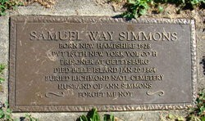
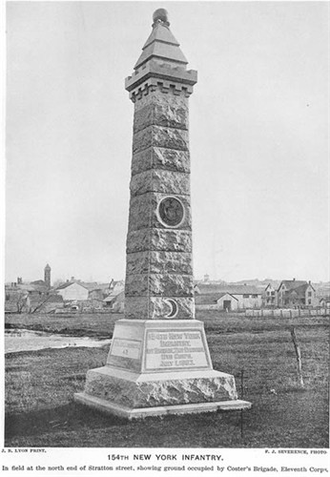
Today, July 1, 150 years ago my 2nd great grandfather’s unit, the New York 154th Infantry Regiment, the “Hardtack Regiment” was engaged in the 1st day of battle at Gettysburg. His name was Samuel Way Simmons (1827-1863). He was a farmer at Great Valley, Cattaraugus County, New York and a family man being married to Ann Murphy. They had six children: Thomas, Ann, Samuel, Hannah (my great grandmother McKernan), Mary, and Harriet. Samuel W. Simmons had enlisted as a private on 25 Aug 1862 in Company H. The unit mustered at Jamestown, NY. The 154th was assigned to the 1st Brigade, 2nd Division of the 11th Corps of the Army of the Potomac. At the battle of Gettysburg the 154th along with the 134th New York, the 27th Pennsylvania, and the 73rd Pennsylvania of Colonel Charles R. Coster’s 1st brigade was deployed at John Kuhn’s brickyard on the Northern outskirts of Gettysburg in attempt to provide a rear guard covering the withdrawal of other elements of the 11th Corps. The effort failed and 154th with the rest of the 11th Corps was swept by on coming Confederate forces from the battlefield North of Gettysburg and fell back to positions on Cemetery Hill South of Gettysburg. In the confusion of the retreat through Gettysburg many Union troops were captured. Samuel Way Simmons was among those captured and was marched south to the prisoner of war camp at Belle Island in the James River at Richmond Virginia. He would try an escape but failed and eventually died of pneumonia in the camp. He was among those whose exact grave location was lost in the fog of war but is believed buried among the unknowns at Richmond National Cemetery and remembered with a Centograph at Holy Cross Roman Catholic Cemetery at Ellicottville, Cattaraugus County, New York. His widow and children were granted a survivor’s pension of $96 a year.
Figure 1: Samuel Way Simmons Centograph at Holy Cross Roman Catholic Cemetery in Ellicottville, NY
Figure 2: 154th NY Infantry Monument at Gettysburg

The story of his escape attempt is told in the following:
Story about Samuel W. Simmons at Belle Island POW camp in Richmond Virginia
From
Wars Relentless Hand – Twelve Tales of Civil War Soldiers
Mark H. Dunklelman, Louisiana State University Press, Baton Rouge
pp 121-122
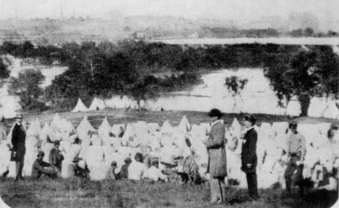
One of Bill's tent mates, Private Samuel W. Simmons of Company H, took a more reckless tack to leave the island: he attempted to escape. Simmons and a company comrade, Private Alfred Matteson, concocted a plan to get over the pen's earthworks and cross the river. Simmons told Bill he would just as soon be shot attempting to escape as stay in the prison and starve to death-"they would," he said, "die there anyhow." Bill tried to dissuade him, but Simmons was determined. On the night of October 14-15, 1863, he and Matteson armed themselves with long poles, bid Bill and the others goodbye, and left the tent. Bill was so certain they would fail and be shot that he lay down with his blanket over his ears, hoping to muffle the blast of the muskets that he felt certain would take his comrades' lives. On receiving a signal from other prisoners that two guards had vacated the northwest corner of the pen, Simmons and Matteson scrambled over the embankment into a ditch and ran along the riverbank until they found a suitable crossing place. Using their poles for balance, they leaped from rock to rock to the middle of the James and then jumped as far as they could into the rushing water Simmons sank to the bottom, bobbed to the surface, and struggled through the cold water, finally crawling ashore in Richmond on his hands and knees. There he surrendered at a Confederate camp.' Matteson was drowned; his corpse was swept downstream until it snagged in a fish net or an eel rack, where it was found on October 20. Matteson's remains were returned to the island and buried by his regimental comrades the following evening. Simmons was escorted to the island on October 20 and confined in a guardhouse. Through cracks in the wall he spied loaves of bread piled against the partition. Using his case knife to saw through some nails, he freed a board so he could get at the bread. He also managed to finagle extra rations, so that by the time he was sent back into the pen, Bill noted, he was "as fat as a hog." But reduced to the usual scanty rations, Simmons's health began to decline. Bill cautioned his friend to take better care of himself, or he would not live very long. Simmons became deeply discouraged and began to court trouble, hoping to return to the guardhouse and the bread pile. He never made it. He died of fever on New Year's Day, 1864.
Figure 3: View of Belle Island Prisoner of War Camp

